**LIST OF EXPERIMENTS(PDA)**

COURSE CODE : CSA1381

COURSE NAME : THEORY OF COMPUTATION

NAME: K.Siva Naga Manoj Kumar

REG NUM: 192111630

**EXPERIMENT NUMBER 13:**

Design PDA using simulator to accept the input string aabb

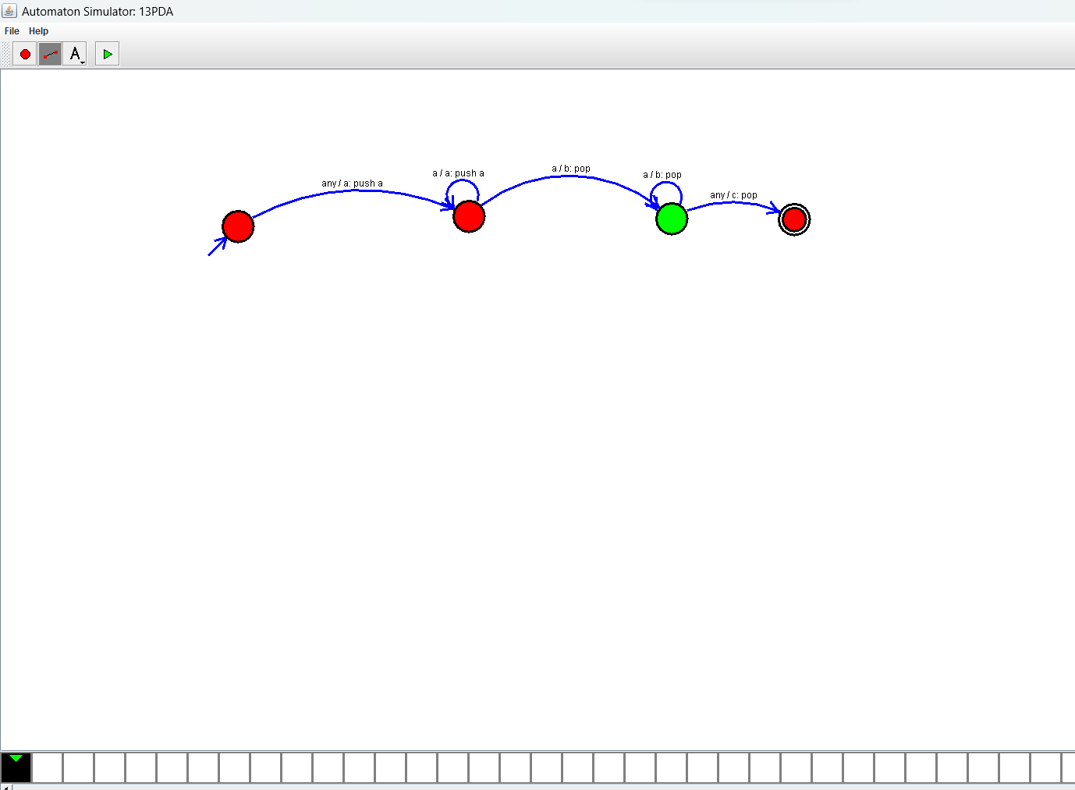

**EXPERIMENT NUMBER 14:**

Design PDA using simulator to accept the input string anb2n

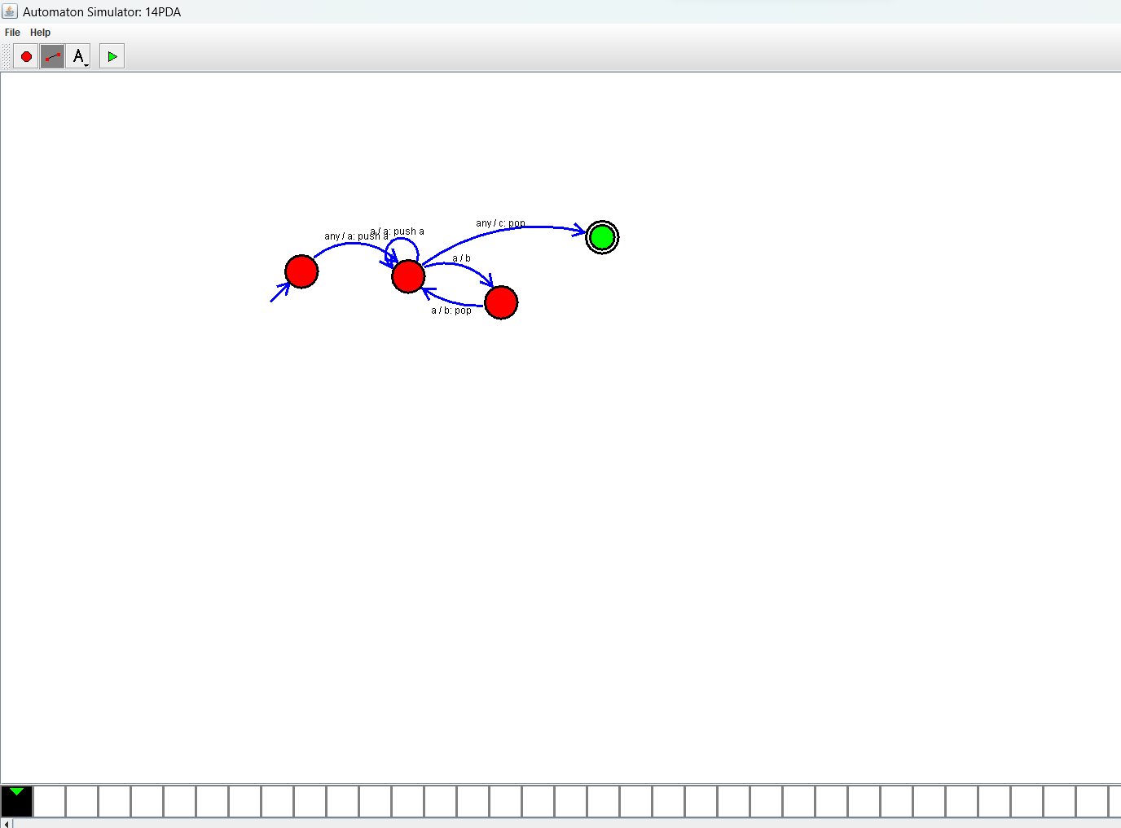

**EXPERIMENT NUMBER 31:**Design PDA using simulator to accept the input string anbn

